**LOVELY PROFESSIONAL UNIVERSITY**

**PROJECT NAME**

**FITNESS CLUB WEBSITE**

**INTERNET PROGRAMMING LANGUAGE**

**CSE326**

**SUBMITTED BY:**

Kumar Tanishq (K19AZ, A21)

Talanki Ganesh Kumar (K19AZ, A23)

Akashdeep Ghosh (K19AZ, A24)

**SUBMITTED TO:**

Ishapreet Kaur mam.

**Introduction**

Our project is to design a website of Fitness club. On the website home page, we can see the whole page is backgrounded with gym interior image. The navigation bar consists of About us, Time table, Trainings, Nutrition and Gallery. For this navigation bar we designed hover effect. The total webpage is divided into four sections that is photo section, register section, about us section and latest events.

In Photo section we used some photos of gym and also designed scroll bar below the photos to scroll the photos in the website. The register button is very simple design with slightly rounded corners with slowly transition and change the color to solid grey.

As given in the question, the Fitness Club logo is placed in left corner and the navigation bar is placed at the top right corner in the website.

The layout of the website is:

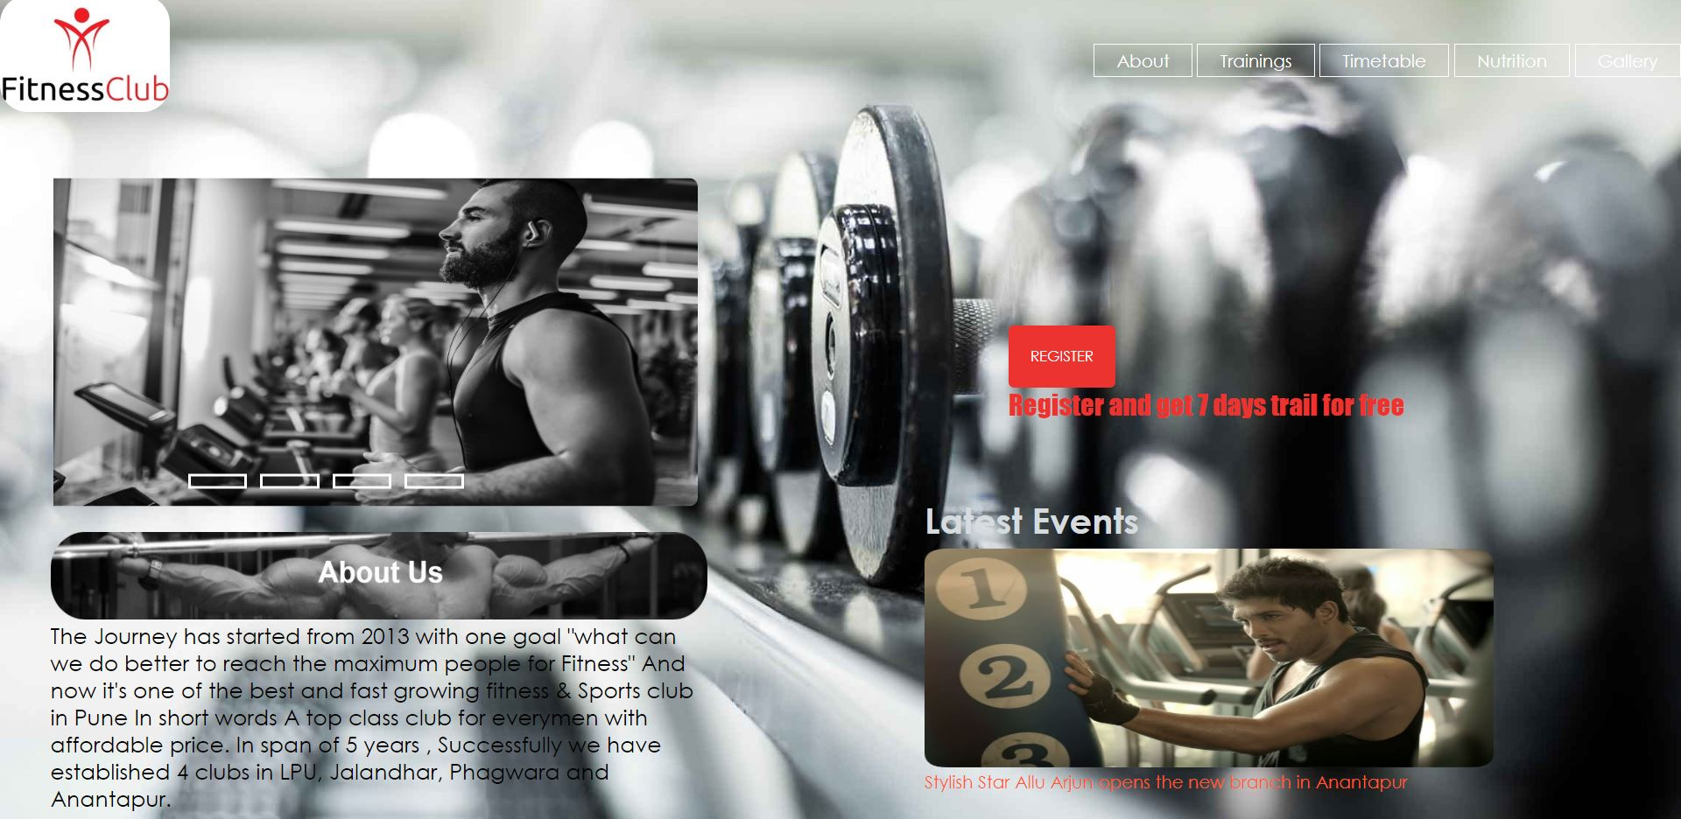

This the final output of the website as per given in the question.

The navigation bar in the website is:



The navigation bar consists of hover effect with transition which shows in given below picture:



The hover: selector is used to select elements when we move mouse over there.

We designed this effect by observing this effect in w3school.com



In photo division we have created by taking size of ¼ th of the screen and applied 4 phothos one by one.By some changes in CSS we created this photo division which is shown in below image.

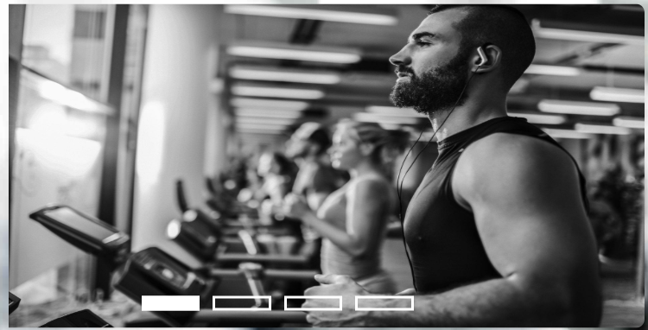

We created the photo slider bar using radio type and styling them in CSS and added hover effect in those input

Boxes.



We designed REGISTER button using webkit-box-shadow, -moz-box-shadow, box-shadow, transition and hover effect. We changed the color and size of the button when cursor moves there.





The image of about us taken from the website <https://www.silverfitnessclub.in> :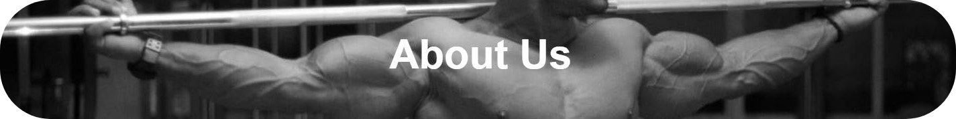

The content of about is also inspired from the above website.

The latest division is created by div tag and added test of LATEST EVENTS and added a photo of movie star to commertialize the website. We created like opening a gym of fitness club by movie star.

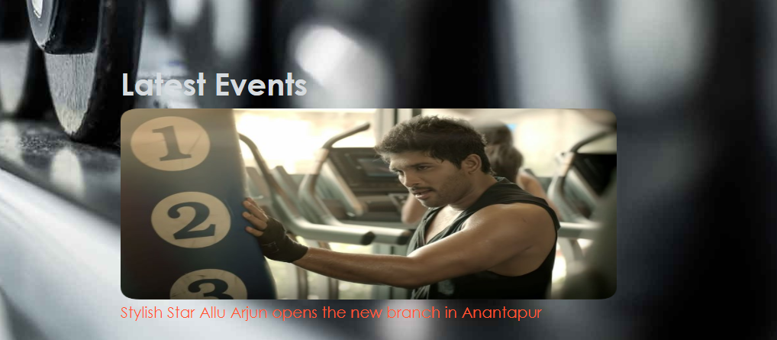

We created a registration form using table and input type as text. We have asked Name, Sur name, DOB, Address, Phone, Email and pin code from the user. We created a separate HTML file and attached this file using href tag in the main project.

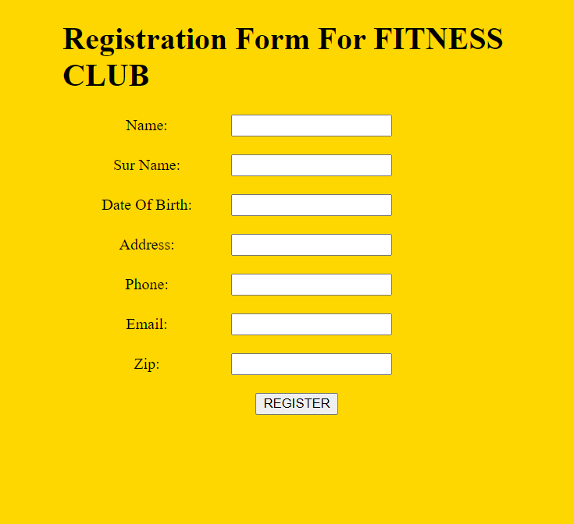

After submitting the information of the user by clicking register button it shows an alert:



The Gallery option is created in another HTML file consists of 4 images of unique size shown side by side. And attached the file in main project. So, it will open when the user clicks the Gallery button in the navigation bar.

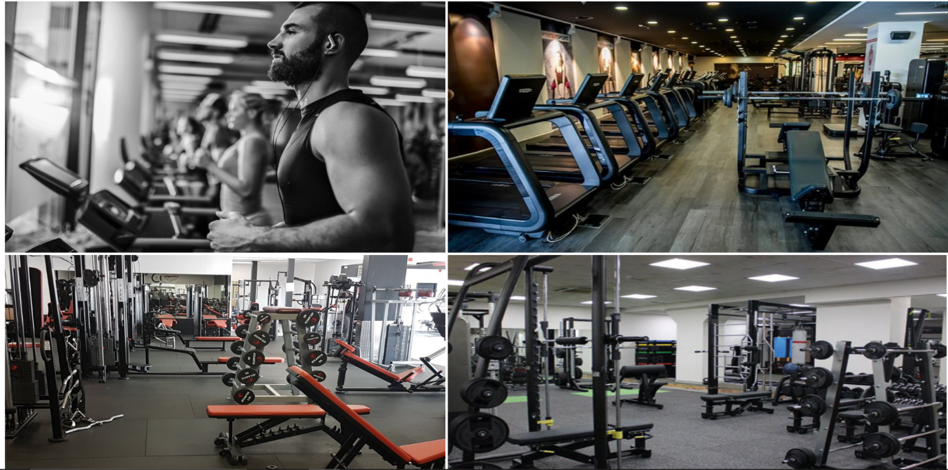

The Time table is created by creating a another HTML file and applied an image as background and attached the file in the main project.

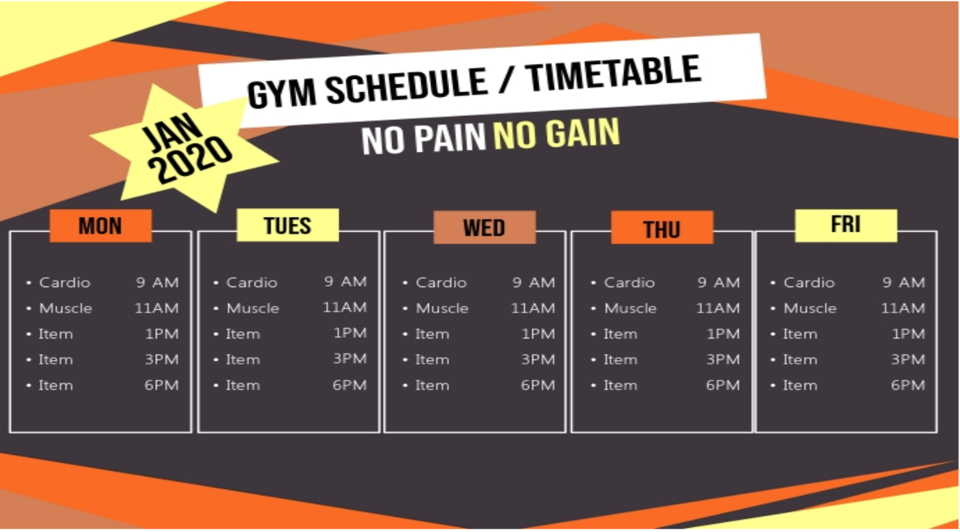

The background image is taken from google. If we want to add a photo on background image, we use position:

absolute; in CSS file:



For rounded corners of photo we use border-radius in CSS file.

Contribution of each members in the group

T Ganesh kumar (23) designed the website with basic requirements as in the given layout and included some parts of CSS and half of the Final report.

Akashdeep Ghosh (24) included in another half of the Final report and Pre-Submission report.

Kumar Tanishq (21) helped in styling in the CSS like colors, sizes etc.

Arjun Kumar(22) DROPOUT.

The video of working of the project is made by T Ganesh kumar(23).

**THANK YOU MAM**